# Ch 14 Lab Exercise – Pathway analysis and Gene Ontology

December 8, 2016. BIO-352.

Last week we explored a microarray data set in its entirety by comparing the overall number of genes that were differentially expressed. This week we will look more closely at the genes that were differentially expressed. We will be asking whether these gene lists reveal a pattern of expression for a particular set of genetic pathways.

Obtain the text files from last week’s lab on Blackboard. These files are the lists of genes from the microarray experiment. I re-worked the analysis after grouping all MVEC samples together (iris, retina, choroid) and did a comparison between HUVEC and MVEC. I also fixed our threshold value to match the Browning et al. paper. (We had logFC set to >2 or <-2, and it should have been >1 or <-1). This produced two lists of genes: an upregulated (higher expression in HUVEC) of 531genes and a downregulated (lower expression in HUVEC) of 567 genes.

Go to DAVID site and upload the affy_id list for the upregulated genes. Follow along with the handout and answer the following questions

1. Under Gene Ontology there are three main categories of GO terms: BP, CC and MF. What do these mean?
2. How many GO BP terms are significantly enriched in the Upregulated gene list (Benjamini P-value <0.05)? What percent of the list has a GO BP term associated with it?
3. Now upload the downregulated list. How many GO BP terms are significantly enriched for the downreulated list? What overall differences in GO terms do you notice?
4. Explore the other types of GO terms (CC and MF) and note any interesting observations.
5. Under Pathways, select the KEGG_PATHWAY Chart and examine the top results for both up and downregulated lists (you can click on the lists and click Use to switch between two uploaded lists)

Next you will upload a modified version of the list containing both sets of genes to the KEGG pathway coloring tool. This list contains both differentially expressed gene sets but labeled by color. Upregulated genes are RED and downregulated genes are GREEN.

Save the image of a KEGG pathway colorized with the genes from your microarray experiment. Write a paragraph of what you did and any observations or findings. Based on your analysis, which handful of genes would you suggest to follow up using reverse genetics methods? What phenotype would you examine in your experiment?

Finding represented pathways from a gene list using DAVID – with significance

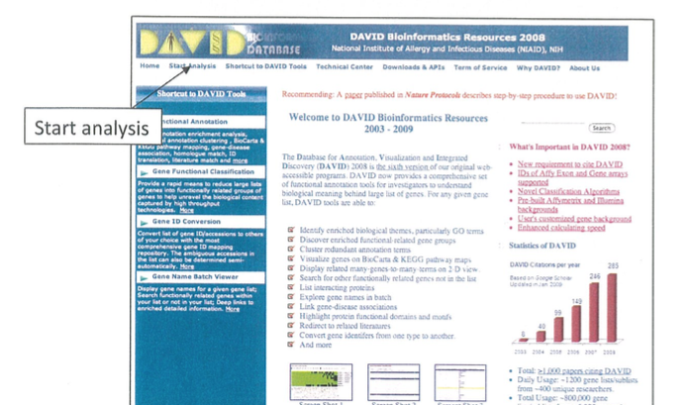

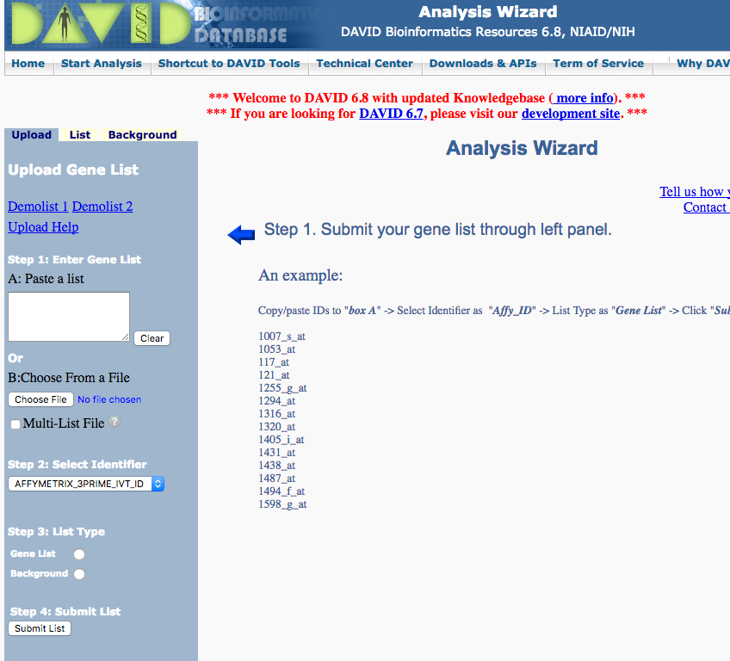

Use Affymetrix_3Prime_IVT_ID as identifier. You can upload both files and rename them. Select as Gene List.

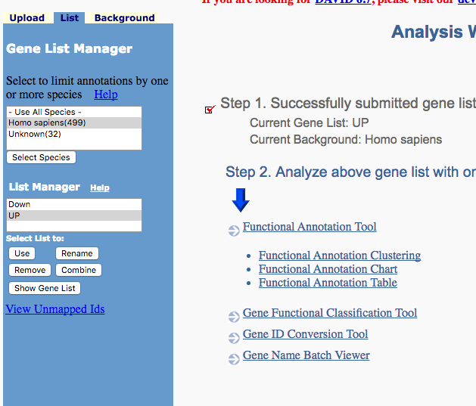

Click on Functional Annotation Tool

Select the gene list you want to use and Click Use

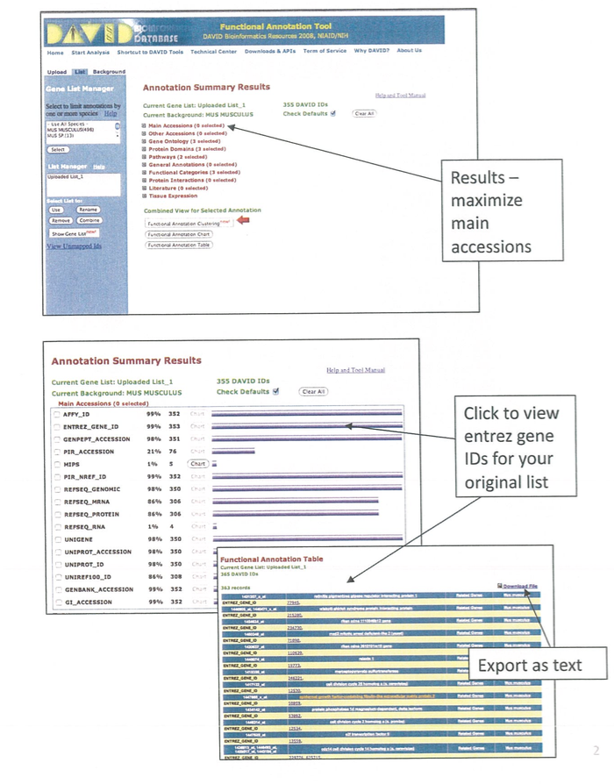

You can export these lists as text, but you don’t need to for today’s exercise

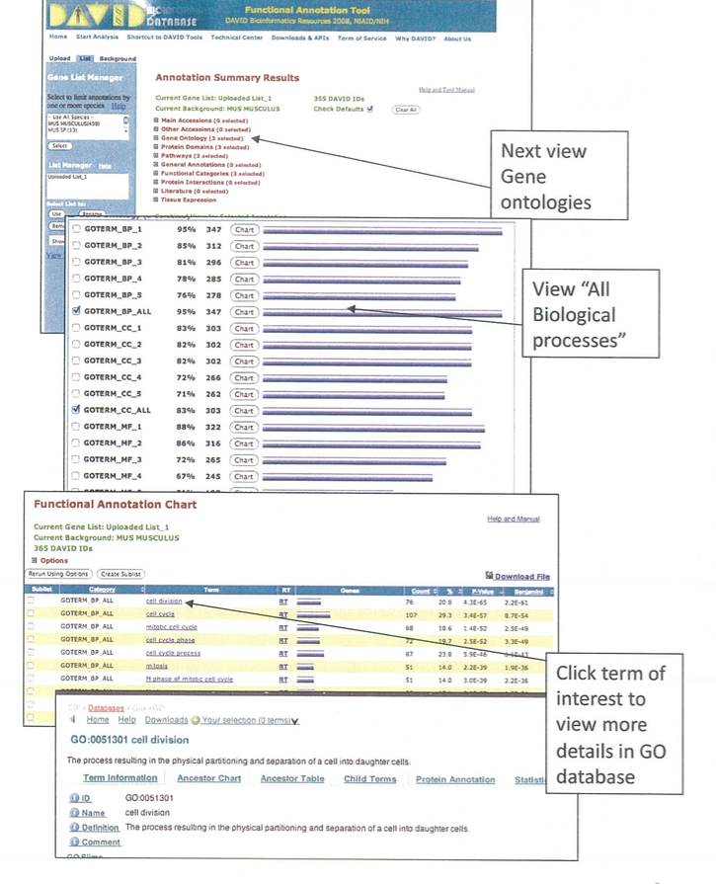

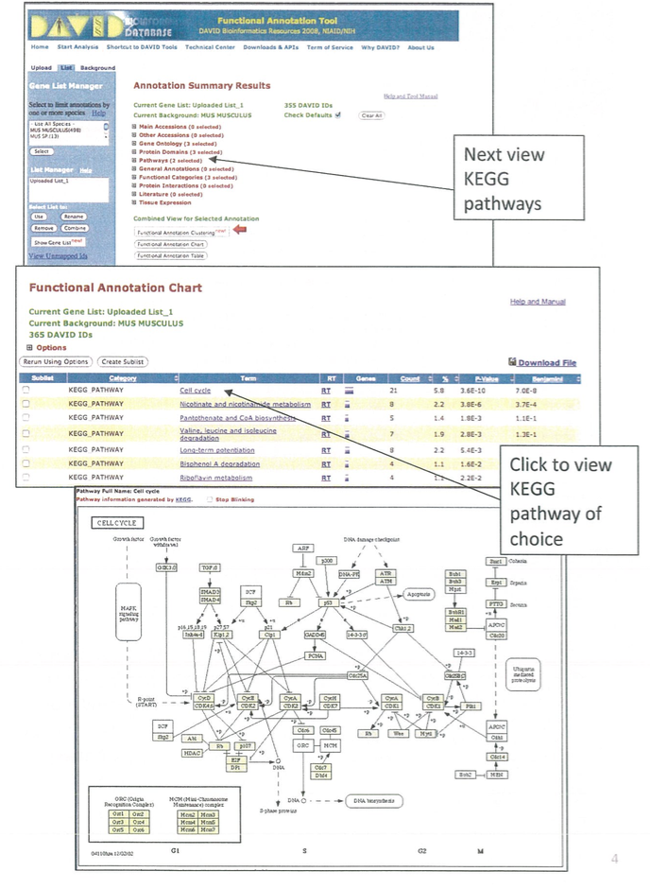

Color Coding Pathways with KEGG



Click Kegg pathway

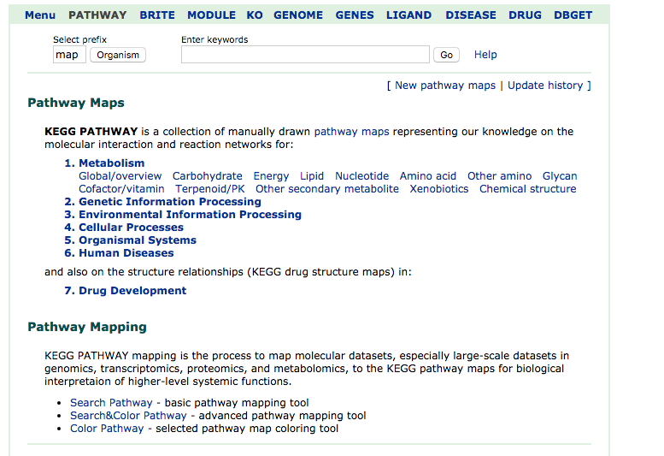

Click Search&Color Pathway

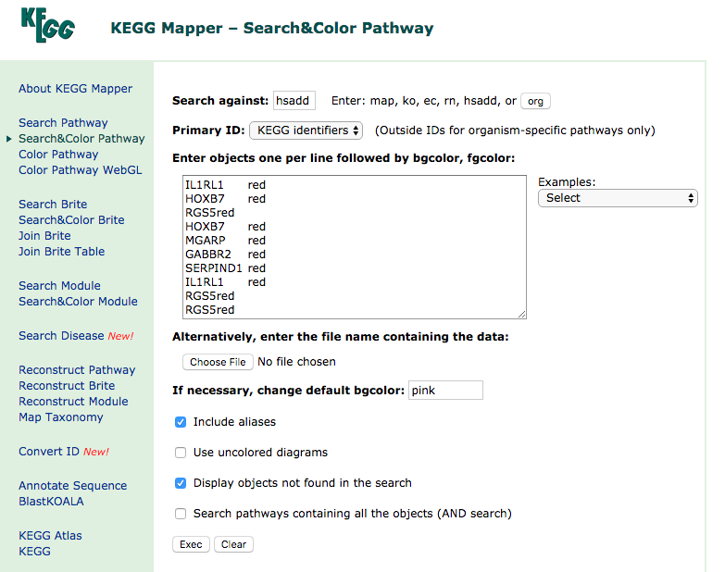

Select hsadd (for homo sapiens drug and disease genes)

Enter in your color coded list with both up and down regulated genes.

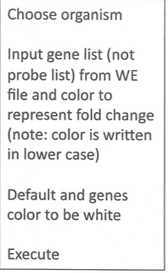

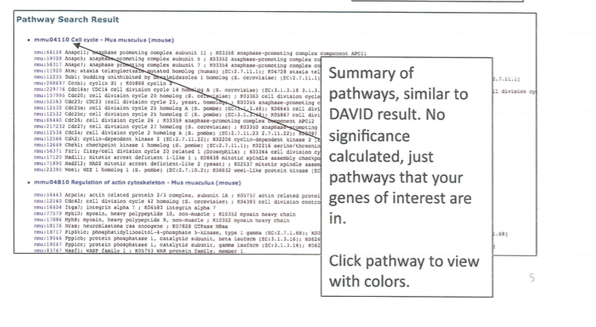

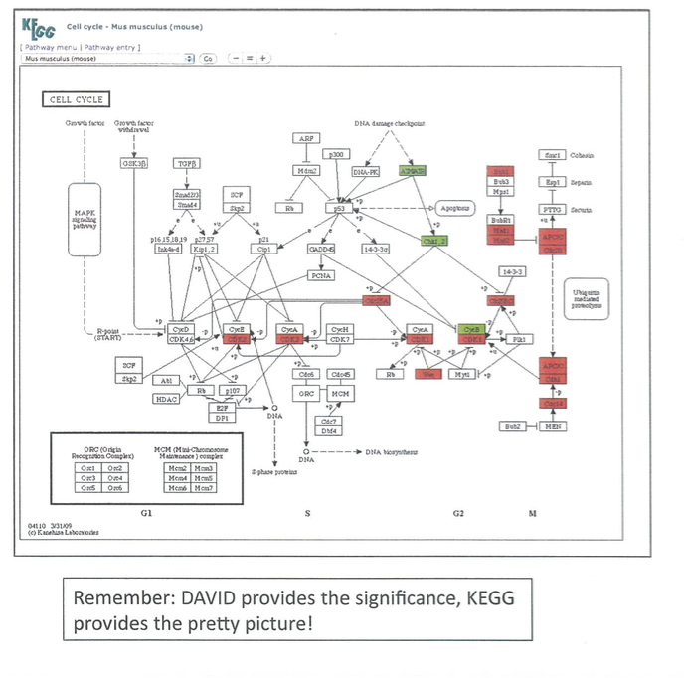

Click on Help button for key to pathway